**“PATIENT MANAGEMENT SYSTEM”**

**CODE:**

// dsa project.cpp : Defines the entry point for the console application.

//

#include "stdafx.h"

#include<iostream>

#include<stdlib.h>

#include<string>

using namespace std;

class Plist

{

private:

struct node

{

string patient_name;

int bed_num ;

int phone;

int age;

int ward_n ;

string ward ;

node *next;

node *prev;

}*head;

public:

Plist()

{

head=NULL;

}

void add_patient_record(int bn, string pn, string w, int wn, int ph, int a) {

node *p, *q;

q = new node;

p = head;

q->patient_name = pn;

q->bed_num = bn;

q->age = a;

q->ward = w;

q->phone = ph;

q->ward_n = wn;

if (head == NULL)

{

q->next = NULL;

q->prev = NULL;

head = q;

}

else if (q->bed_num < p->bed_num)

{

q->next = head;

q->prev = NULL;

head->prev = q;

head = q;

}

else if (q->bed_num == p->bed_num)

{

cout << "Patient with bed number " << bn << " already exists.\n";

delete q;

return;

}

else

{

while (p->next != NULL)

{

if (q->bed_num == p->bed_num || (q->bed_num > p->bed_num && q->bed_num < p->next->bed_num))

{

cout << "Patient with bed number " << bn << " already exists.\n";

delete q;

return;

}

p = p->next;

}

// If the new patient has the highest bed number, add it at the end

p->next = q;

q->prev = p;

q->next = NULL;

}

}

void traverse()

{

node *p;

p=head;

while(p!=NULL)

{

cout<<"\t*!*!*!*!*!*!*!*!*!*!*!*!*!*!*!*!*!*!*!*!*!*!*!*"<<endl<<endl;

cout<<"PATIENT NAME = "<<p->patient_name<<endl;

cout<<"AGE = "<<p->age<<endl;

cout<<"PHONE NUMBER = "<<p->phone<<endl;

cout<<"WARD(MALE OR FEMALE) = "<<p->ward<<endl;

cout<<"WARD NUMBER = "<<p->ward_n<<endl;

cout<<"BED NUMBER = "<<p->bed_num<<endl;

cout<<"\t*!*!*!*!*!*!*!*!*!*!*!*!*!*!*!*!*!*!*!*!*!*!*!*"<<endl<<endl;

p=p->next;

}

}

void del_patient_record(int value)

{

node *p, *temp;

p = head;

if (head == NULL)

{

cout << "No Record\n";

} else {

while (p != NULL && p->bed_num != value) {

temp = p;

p = p->next;

}

if (p == NULL)

{

cout << "Patient with bed number " << value << " not found.\n";

}

else

{

if (p == head)

{

head = p->next;

if (head != NULL)

{

head->prev = NULL;

}

}

else

{

temp->next = p->next;

if (p->next != NULL)

{

p->next->prev = temp;

}

}

delete p;

cout << "Patient with bed number " << value << " deleted successfully.\n";

}

}

}

void login()

{

string u;

string use="user";

string pass ="123";

do

{

cout<<endl<<endl<<endl<<endl;

cout<<"\t*!*!*!*!*!*!*!*!*!*!*!*!*!*!*!*!*!*!*!*!*!*!*!*"<<endl<<endl;

cout<<"\t******************* USERNAME ****************** "<<endl<<endl;

cout<<"\tENTER USERNAME = ";

cin>>u;

cout<<endl;

if(u=="user");

{

cout<<"\t******************* PASSWORD ******************"<<endl<<endl;

cout<<"\tENTER PASSWORD = ";

cin>>pass;

cout<<endl;

cout<<"\t*!*!*!*!*!*!*!*!*!*!*!*!*!*!*!*!*!*!*!*!*!*!*!*"<<endl<<endl;

if(pass != "123")

{

cout<<endl<<endl<<endl<<endl;

cout<<"\t****##***##***##***##***##***##****##***##****"<<endl<<endl;

cout<<"\t***##*********** LOGIN FAILED ************##*** "<<endl<<endl;

cout<<"\t****##***##***##***##***##***##****##***##****"<<endl<<endl;

cout<<"\t***##************ ACCESS DENIED **********##*** "<<endl<<endl;

cout<<"\t****##***##***##***##***##***##****##***##****"<<endl<<endl;

}

else

{

cout<<endl<<endl<<endl<<endl;

cout<<"\t**%**%**%**%**%**%**%**%**%**%**%**%**%**%**%**"<<endl<<endl;

cout<<"\t**%****%****%** LOGIN SUCCESSFULLY ****%****%** "<<endl<<endl;

cout<<"\t**%**%**%**%**%**%**%**%**%**%**%**%**%**%**%**"<<endl<<endl;

cout<<"\t****%****%****%** ACCESS GRANTED ****%****%**** "<<endl<<endl;

cout<<"\t**%**%**%**%**%**%**%**%**%**%**%**%**%**%**%**"<<endl<<endl;

cout<<endl<<endl<<endl<<endl;

cout<<endl<<endl<<endl<<endl;

}

}

}

while(pass!="123");

}

};

int _tmain(int argc, _TCHAR* argv[])

{

int a;

string p,u;

Plist pl;

cout<<"\t***********************************************"<<endl;

cout<<"\t***********************************************"<<endl<<endl;

cout<<"\t******* PATIENT MANAGEMENT SYSTEM *******"<<endl<<endl;

cout<<"\t******* WELCOME TO LOGIN PAGE ************"<<endl<<endl;

cout<<"\t***********************************************"<<endl;

cout<<"\t***********************************************"<<endl<<endl;

cout<<endl<<endl<<endl<<endl;

pl.login();

cout<<"\t***********************************************"<<endl;

cout<<"\t***********************************************"<<endl<<endl;

cout<<"\t******* PATIENT MANAGEMENT SYSTEM *******"<<endl<<endl;

cout<<"\t************** WELCOME ******************"<<endl<<endl;

cout<<"\t***********************************************"<<endl;

cout<<"\t***********************************************"<<endl<<endl;

do

{

cout<<" Enter your choice "<<endl<<endl;

cout<<" 1 - PRESS 1 To Enter Patient Name "<<endl;

cout<<" 2 - PRESS 2 To Delete Patient Record "<<endl;

cout<<" 3 - PRESS 3 To Show Full Patient List "<<endl;

cout<<" 4 - PRESS 4 To Exit "<<endl<<endl;

cin>>a;

while((a<1)||(a>4))

{

cout<<"\n Enter the valid choice"<<endl;

cin>>a;

cout<<endl;

}system("CLS");

switch(a)

{

case 1:

{

int y,l,o,a;

string name;

string dep;

cout<<" ----- TO INSERT PATIENT DATA ----- "<<endl<<endl;

cout<<" Enter Patient Name = ";

cin>>name;

cout<<" Enter Phone Number = ";

cin>>l;

cout<<" Enter Age = ";

cin>>a;

cout<<" Enter Ward(M/F) = ";

cin>>dep;

cout<<" Enter Ward Number = ";

cin>>o;

cout<<" Enter Patient Bed Number = ";

cin>>y;

pl.add_patient_record(y,name,dep,o,l,a);

cout<<endl;

break;

system("CLS");

}

case 2:

{

int z;

cout<<" ----- TO DELETE PATIENT DATA ----- "<<endl<<endl;

cout<<" Enter the Bed number Of patient "<<endl;

cin>>z;

pl.del_patient_record(z);

break;

system("CLS");

}

case 3:

{

cout<<endl;

cout<<" ----- TO DISPLAY Full Patient LIST ---- "<<endl;

cout<<"*************************************************"<<endl<<endl;

pl.traverse();

cout<<endl;

cout<<endl<<endl;

break;

system("CLS");

}

case 4:

{

exit(0);

break;

}

}

}

while((a>=1)&&(a<=4));

cout<<endl;

system("pause");

return 0;

}

**OUTPUT:**

* **Patient information on login page:**

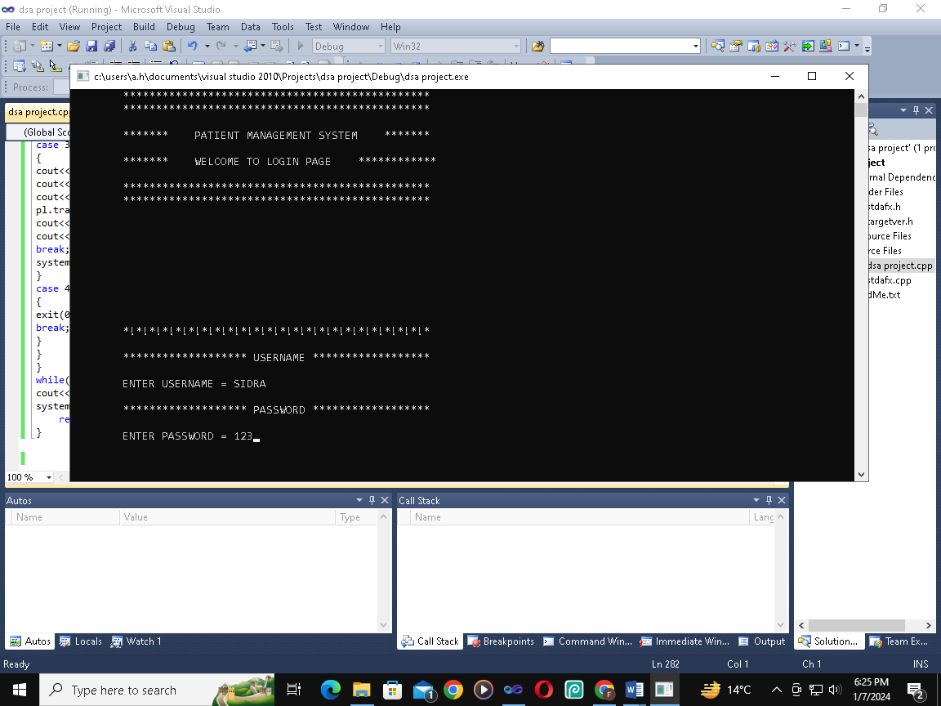

* **Patient login successfully access granted:**

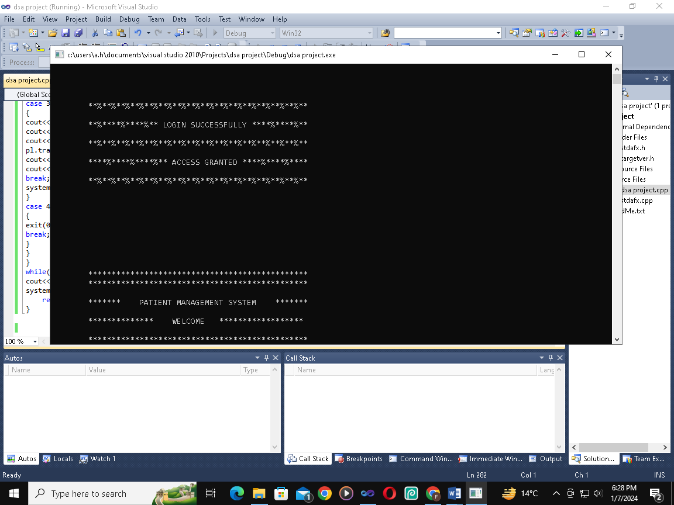

* **Welcome to Patient Management system :**

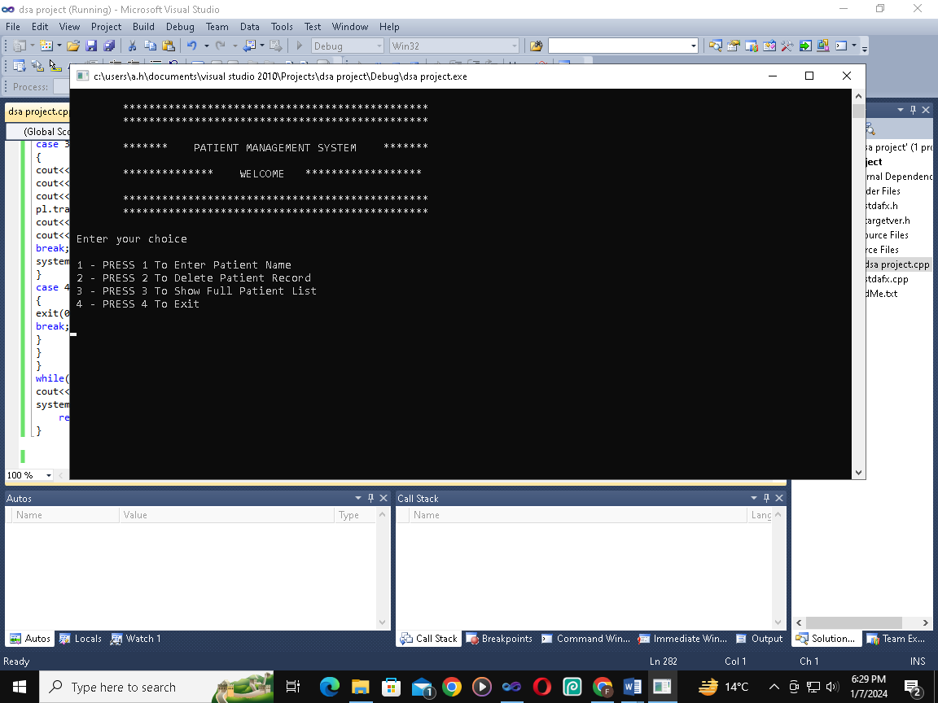

* **To insert patient data press 1 :**

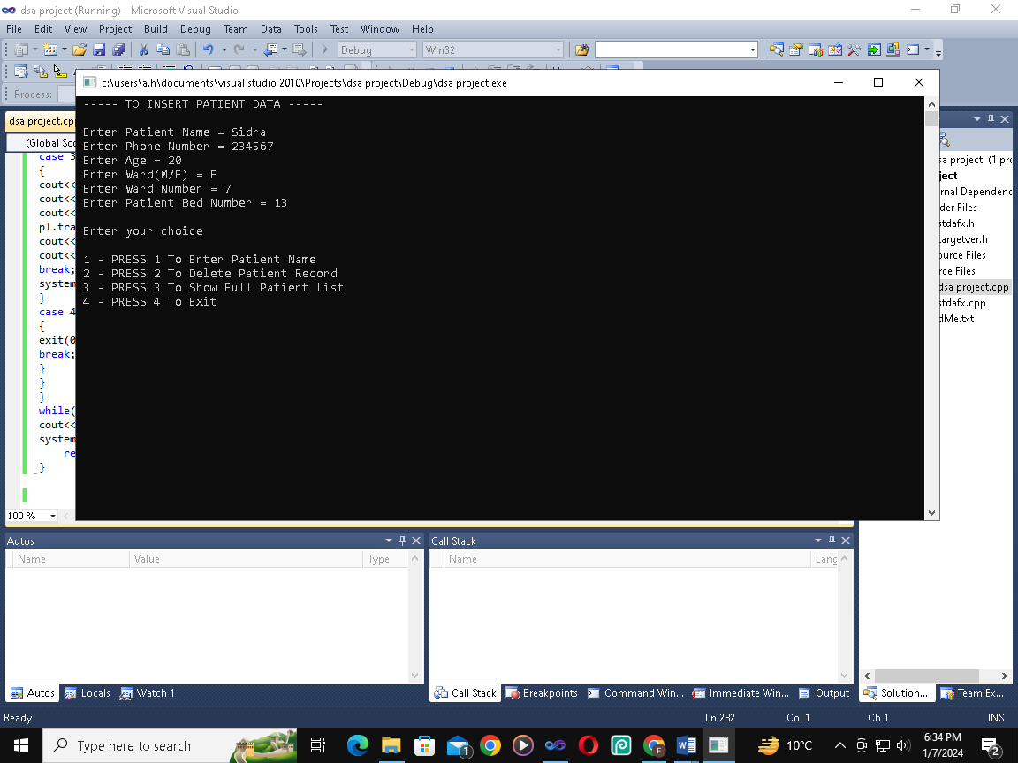

* **To delete patient data press 2 :**

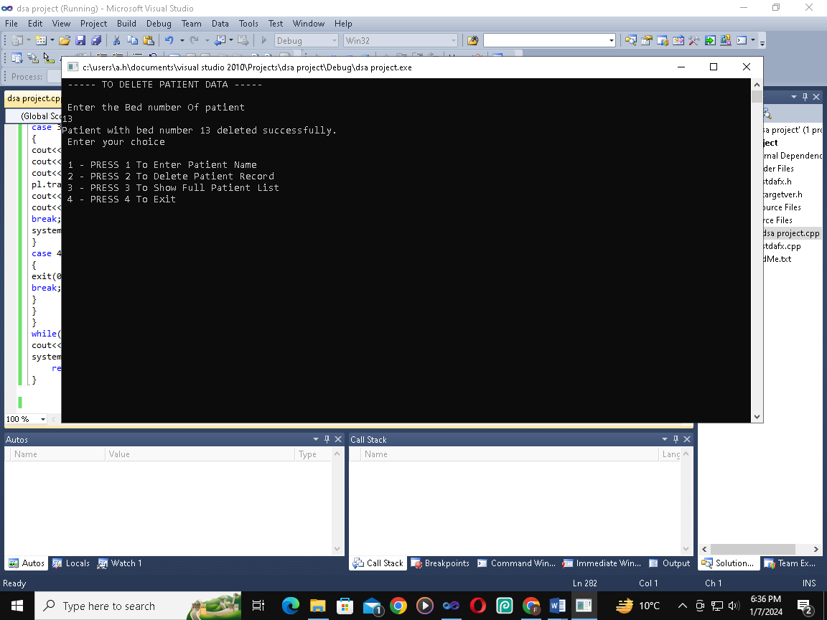

* **To display full patient list press 3 and for exit press 4:**

